Lab 7: Jeremy Howell, Nhi Pham

Publication.h

#ifndef PUBLICATION_PUBLICATION_H

#define PUBLICATION_PUBLICATION_H

#include <iostream>

#include <string>

using namespace std;

class Publication {

public:

//Declare two functions getData and putData

Publication();

Publication(string ti, float pri);

void getData();

void putData() const;

private:

//Declare title and price

std::string title;

float price;

};

#endif //PUBLICATION_PUBLICATION_H

Publication.cpp

#include "Publication.h"

#include <iostream>

using namespace std;

Publication::Publication()

{

title = "N/A";

price = 0;

};

Publication::Publication(string ti, float pri) {

title = ti;

price = pri;

}

//Define the function getData to get title and price

void Publication::getData() {

cout << "Enter the title: " << endl;

getline(cin >> ws, title);

cout << "Enter the price: " << endl;

cin >> price;

};

//Define the function putData to get title and price

void Publication::putData() const {

cout << "The title is: " << title << endl;

cout << "The price is: $" << price << endl;

}

Sales.h

#ifndef PUBLICATION_SALE_H

#define PUBLICATION_SALE_H

#include <iostream>

using namespace std;

class Sale {

public:

Sale();

//Declare functions getData and putData

void getData();

void putData();

private:

//Declare an array to store sales for three months

float saleArray[3];

};

#endif //PUBLICATION_SALE_H

Sales.cpp

#include "Sales.h"

#include <iostream>

using namespace std;

Sale::Sale() {

for (int i = 0; i < 3; i++) {

saleArray[i] = 0;

}

}

void Sale::getData() {

for (int i = 0; i < 3; i++) {

cout << "Enter sale amount: " << endl;

cin >> saleArray[i];

}

}

void Sale::putData() {

cout << "Three months of sales are: " << endl;

for (int i = 0; i < 3; i++) {

cout << '$' << saleArray[i] << endl;

}

}

Book.h

//Class Book is created from classes Publication and Sales

#ifndef PUBLICATION_BOOK_H

#define PUBLICATION_BOOK_H

#include "Publication.h"

#include "Sales.h"

class Book: public Publication, public Sale {

private:

int pageCount;

public:

Book();

void getData();

void putData();

};

#endif //PUBLICATION_BOOK_H

Book.cpp

#include "Publication.h"

#include "Sales.h"

#include "Book.h"

Book::Book() {

Publication();

Sale();

pageCount = 0;

}

void Book::getData() {

Publication::getData();

Sale::getData();

cout << "Enter page count of the book: " << endl;

cin >> pageCount;

}

void Book::putData() {

Publication::putData();

Sale::putData();

cout << "Page count of the book is: " << pageCount << endl;

cout << endl;

}

Digital.h

#ifndef PUBLICATION_DIGITAL_H

#define PUBLICATION_DIGITAL_H

#include "Publication.h"

#include "Sales.h"

class Digital : public Publication, public Sale {

private:

int storageCap;

public:

Digital();

void getData();

void putData();

};

#endif //PUBLICATION_DIGITAL_H

Digital.cpp

#include "Digital.h"

#include "Publication.h"

#include "Sales.h"

#include <iostream>

Digital::Digital() {

Publication();

Sale();

storageCap = 0;

}

void Digital::getData() {

Publication::getData();

Sale::getData();

cout << "Enter storage capacity in MG bytes: " << endl;

cin >> storageCap;

}

void Digital::putData() {

Publication::putData();

Sale::putData();

cout << "Storage capacity in MG bytes is: " << storageCap << endl;

cout << endl;

}

Main.cpp

#include "Sales.h"

#include "Publication.h"

#include "Book.h"

#include "Digital.h"

#include <iostream>

#include <string>

using namespace std;

int main() {

Book book;

Digital digital;

book.getData();

book.putData();

cout << endl;

digital.getData();

digital.putData();

cout << endl;

return 0;

}

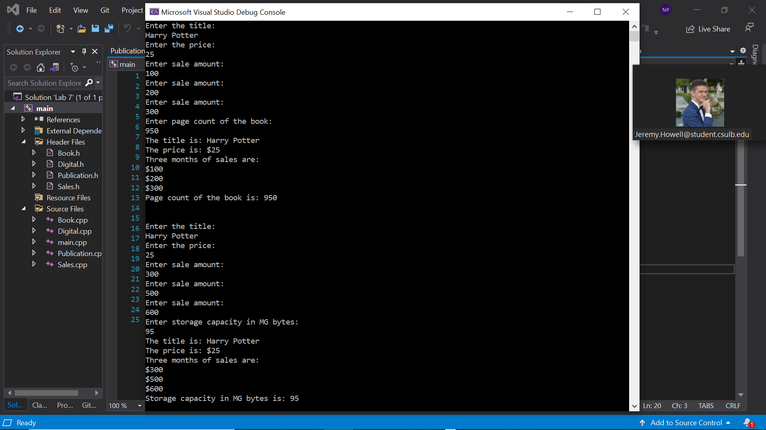

Demonstrated at 11:26 am on 9/30/2021